**Astable Multivibrator**

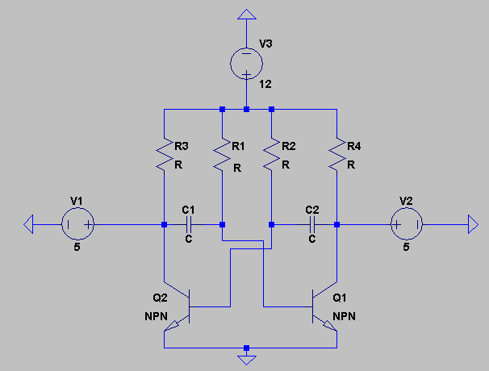

Mention that our signal is Non-sin wave, therefore we choose astable multivibrator circuit.

Basic information

C1 = C2 R1 = R2

For the period time,

T = t1+t2

t1 = 0.69C1R2

t2 = 0.69C2R1